# Raosaheb Wangde Master Charitable Trust’s

# Dnyanshree Institute of Engineering & Technology, Sajjangad Road, Satara.

# BTech Computer Science and Engineering

# Project Synopsis

**Title of the Project: Land Registration System Using Blockchain**

# Category of project: In Campus.

**1.Area/Domain:** Blockchain

**2. Introduction:**

Land registration systems play a vital role in ensuring secure property ownership and economic development. However, traditional methods are often plagued by inefficiencies, corruption, lack of transparency, and disputes over property ownership. These challenges hinder economic progress and create significant barriers to legal governance and secure property transactions. To address these pressing issues, the Blockchain-Based Land Registration System presents an innovative approach, leveraging blockchain technology to transform the way land records and property transactions are managed.

This system utilizes the decentralized and immutable nature of blockchain technology to create a secure and transparent framework for recording land ownership and transactions. By storing data on a distributed ledger, the system ensures that records are tamper-proof and verifiable, reducing the risk of forgery and unauthorized modifications. Blockchain’s ability to maintain a single source of truth across multiple stakeholders eliminates discrepancies and builds trust among all parties involved. Additionally, the system integrates smart contracts, which are self-executing programs designed to automate processes such as the transfer of property ownership upon meeting predefined conditions. This removes the need for intermediaries, minimizes delays, and reduces the risk of errors or fraudulent activities, making the process more efficient and reliable.

To address the need for handling large volumes of property-related documents, the system incorporates off-chain storage solutions like the InterPlanetary File System (IPFS). This ensures efficient storage while maintaining accessibility and the integrity of critical data. Moreover, digital identity verification mechanisms such as Aadhaar-based KYC services enhance user authentication, ensuring that only legitimate users can access and conduct transactions within the platform. These features collectively create a system that is not only secure and transparent but also scalable and user-friendly.

The adoption of this blockchain-based solution has the potential to revolutionize the land registration process, creating a system that is more efficient, transparent, and accessible. By eliminating traditional bottlenecks and ensuring the security of transactions, this system addresses the core challenges of land administration while also offering future possibilities for integration with urban planning, tax monitoring, and land-use analytics. This project represents a significant step forward in modernizing land registration and property management, fostering trust, efficiency, and economic development in the process.

# 3.Literature Survey

[1] Blockchain-Based Secure Land Registration System (2023): This paper introduces a blockchain-based framework for land registration that leverages Ethereum and smart contracts to enhance transparency, security, and immutability. It addresses critical issues such as ownership disputes and fraudulent activities by employing smart contracts to automate key processes like land verification and ownership transfer. The proposed system ensures efficient, tamper-proof operations, revolutionizing traditional land registration methods.

[2] Implementation of Blockchain for Land Registration in India (2023): This study presents an end-to-end digital land registration system leveraging blockchain technology to ensure transparent and secure transactions. The framework integrates tools for mapping land details and uses smart contracts to automate processes such as user verification and ownership transfer. By addressing issues like corruption and delays in traditional systems, the study highlights the transformative potential of blockchain in land registration.

3] Land Records System Using Hybrid Blockchain (2023): This paper proposes a hybrid blockchain framework that combines public and private blockchain functionalities to improve land record management in India. The system ensures secure, transparent, and efficient transactions verified by government nodes, addressing vulnerabilities in centralized systems. By balancing accessibility with the protection of sensitive data, the model provides a robust solution for modernizing land record systems.

[4] A Novel Blockchain Framework for Land Registration (2023): This research presents a tailored blockchain framework for land registration in India, addressing critical challenges like scalability and integration. It emphasizes the benefits of decentralization and tamper-proof records in minimizing fraud and reducing legal disputes. The framework discusses practical implementation strategies, including the use of smart contracts to automate ownership verification and transfer processes. Additionally, the study explores regulatory considerations necessary for blockchain adoption, ensuring alignment with Indian legal and administrative systems. By proposing a scalable and efficient model, the research demonstrates the transformative potential of blockchain in modernizing India’s land registration processes.

# 4.Problem Statement

Land registration systems worldwide struggle with inefficiency, high costs, and vulnerability to fraud due to outdated, paper-based processes that lack transparency and security. This problem often leads to record tampering, unauthorized transactions, and legal disputes, undermining trust among stakeholders and stifling economic growth. To address these challenges, this project proposes a blockchain-based land registration system that ensures secure, transparent, and immutable records of land ownership. Leveraging blockchain’s decentralized, tamper-proof structure, the system aims to reduce fraud, streamline transactions, and enhance accessibility, offering a scalable solution that could transform land registration practices globally by fostering trust and economic development.

# 5.Objectives

1. **Enhance Transparency and Security**: To create a tamper-proof, decentralized platform for managing land records, ensuring secure and transparent transactions.
2. **Automate Processes**: To streamline property registration, ownership transfers, and tax compliance through smart contracts, reducing manual effort and delays.
3. **Prevent Fraud and Disputes**: To eliminate risks such as double-selling and data manipulation by maintaining an immutable ledger of property ownership and transactions

# 6. Block Diagram With Blockwise Explanation

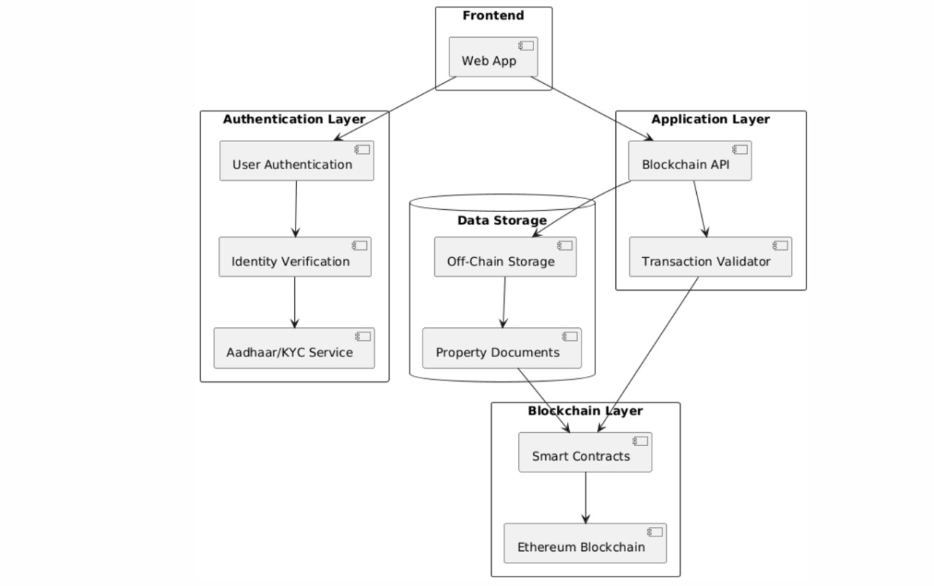

Fig.1. Block Diagram

**Frontend Layer:**

* Includes a web application serving as the user interface, allowing users to interact with the system for land registration and related operations.

**Authentication Layer:**

* Manages user authentication, ensuring only authorized individuals can access the system.
* Performs identity verification using integrated Aadhaar/KYC services to validate user details.

**Application Layer:**

* Hosts the Blockchain API, which acts as the interface between the frontend and the blockchain.
* Contains a transaction validator to ensure all transactions adhere to predefined rules before they are processed.

**Data Storage:**

* Uses off-chain storage (e.g., IPFS) for storing large files like property documents, which are linked securely to the blockchain.

**Blockchain Layer:**

* Implements smart contracts to automate land registration, property transfers, and validation processes.
* Leverages the Ethereum Blockchain for maintaining immutable and decentralized transaction records.

# 

# 7. Specifications

# Software Specifications:

1. Solidity
2. Remix IDE
3. Node.js
4. MetaMask
5. Web3.js
6. React.js
7. Ethereum Blockchain

**Hardware Specifications**:

1. RAM- 4GB
2. Processor- intel i3/ Ryzen 3
3. Hard Disk- 256GB

# 8.Significance

The blockchain-based land registration system is significant as it ensures transparency, security, and trust in property transactions. It eliminates fraud and disputes through immutable records and decentralized management. Automation via smart contracts streamlines processes, reducing delays and costs. The system also protects sensitive data with advanced cryptographic techniques. By aligning with legal standards, it offers a scalable, future-ready solution for efficient land administration. This system is salable, which means it can be applied globaly to streamline and registration processes and improve legal certainty in real estate transactions. Overall, it offers significant, economic, enviromental and administrative benefits, especially in terms of reducing fraudulent activities and improving trust in land markets.

# 9.Methodology

The methodology for implementing a blockchain-based land registration system begins with identifying the challenges in the current system, such as fraud, inefficiencies, and lack of transparency, followed by defining objectives like enhanced security, automation, and accountability. Next, a detailed analysis of stakeholder requirements and blockchain platforms (e.g., Ethereum or Hyperledger) is conducted to design a decentralized architecture. This includes modules for property registration, ownership transfer, and transaction verification, supported by smart contracts to automate processes and off-chain storage for large files. The system is developed in phases, starting with coding and testing smart contracts, creating APIs for blockchain interaction, and building a user-friendly front-end with tools like React.js and web3.js. Rigorous testing, including unit, integration, and load testing, ensures reliability and scalability. After deployment on a blockchain network and hosting the application on a cloud platform, the system is monitored and maintained with updates for legal compliance and performance improvements.

# 

# 10.Selection Criteria For Platforms And Tools

**Solidity**: A programming language designed for writing smart contracts, essential for implementing transaction logic and automation on the Ethereum blockchain.

**Remix IDE**: A browser-based development environment that provides ease of writing, testing, and deploying smart contracts.

**Node.js**: Enables backend development with asynchronous operations and integration of blockchain APIs like Web3.js.

**MetaMask**: A browser extension or mobile wallet to interact with Ethereum blockchain, used for managing user accounts and signing transactions.

**Web3.js**: A JavaScript library that facilitates interaction between the frontend and the Ethereum blockchain.

**Ethereum Blockchain**: Provides a decentralized platform for secure, immutable, and transparent data storage and processing.

# 

# 11.Proposed Platforms

* Frontend: React.js, HTML, CSS, Javascript
* Blockchain: Ethereum, Solidity
* Libraries: Web3.js, Ethers.js
* Identity Verification: Aadhaar, KYC Integration
* Development Tools: Remix IDE, Truffle Suite, Ganache

# 12.References

1. Nakamoto, S. (2008). *Bitcoin: A Peer-to-Peer Electronic Cash System*.
2. Zheng, Z., Xie, S., Dai, H., Chen, X., & Wang, H. (2017). "An Overview of Blockchain Technology: Architecture, Consensus, and Future Trends". *IEEE International Congress on Big Data*.
3. Sood, M., & Pandey, M. (2018). "Blockchain-Based Framework for Securing Land Records". *International Journal of Scientific Research and Engineering Development (IJSRED)*.
4. Zheng, S., & Cui, J. (2019). "Applications of Blockchain in Real Estate and Land Registration". *International Conference on Blockchain and Cryptocurrency*.
5. Joseph, A., & Mathew, G. (2020). "Secure and Transparent Land Registry System using Blockchain". *International Journal of Computer Applications (IJCA)*.

# Name & Signatures of Students:

|  |  |  |  |  |
| --- | --- | --- | --- | --- |
| Sr.No. | Name of Student | Roll No. | PRN/Enrollment No. | Signature of Student |
| 1 |  |  |  |  |
| 2 |  |  |  |  |
| 3 |  |  |  |  |
| 4 |  |  |  |  |

Signature: Signature:

Name: Name:

[Co-Guide] [Guide]

Signature: Signature:

Name: Name:

[Dept.Project Coordinator] [Head of Department]